Project Design Phase-I
Problem – Solution Fit Template

Date | 1 November 2026
Team ID
Project Name | Electric Vehicle Market Performance & insights
Maximum Marks | 2 Marks

Problem – Solution Fit Template:
- The Problem–Solution Fit identifies the challenges faced by EV market analysts and explains how the proposed solution addresses them. The project provides an interactive Tableau dashboard using data processed through Python and Snowflake.
Purpose
- Solve EV market data analysis problems.
- Compare manufacturers and vehicle categories.
- Analyze sales, pricing, driving range, and regional performance.
- Provide meaningful insights through interactive dashboards.
- Support informed EV market decisions

Template:
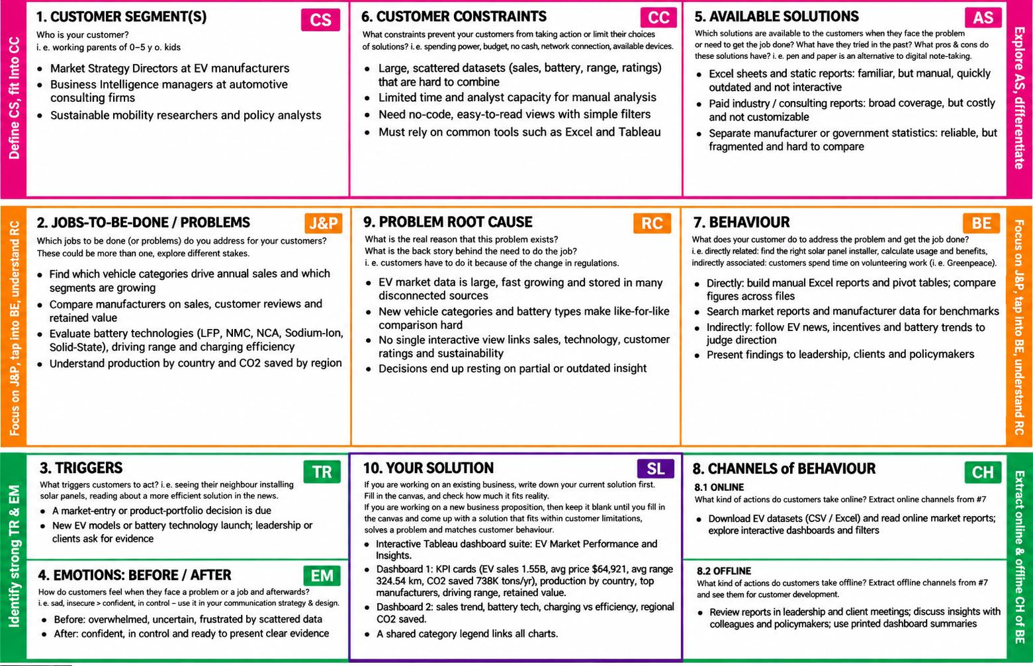
References:
- https://www.ideahackers.network/problem-solution-fit-canvas/
- https://medium.com/@epicantus/problem-solution-fit-canvas-aa3dd59cb4fe

